Smart Parking Platform
Project Management Document
Patrick Brinkley
University of Houston
CIS 4374 | Information Systems Project Management
Dr. Otto Dobretsberger
Version 4.0
September 31, 2026

Table of Contents
1. Existing Software Landscape 4
2. Vision and Scope 5
2.1 Project Acquisition 5
2.2 Company Introduction 5
2.3 Project Overview 5
3. Software Requirements Specification (SRS) 5
3.1 Introduction 5
3.1.1 Purpose 5
3.1.2 Scope 6
3.2 Overall Description 6
3.2.1 Users 6
3.2.2 System Environment 6
3.2.3 Constraints 6
3.2.4 Assumptions 7
3.3 Functional Requirements 7
3.4 Non-Functional Requirements 8
3.5 Use Cases 9
Use Cases
Use Case 1 – Register Account 10
Use Case 2 – Log In. 10
Use Case 3 – Register Vehicle 10
Use Case 4 – Find Parking Garage 11
Use Case 5 – View Real-Time Parking Availability 11
Use Case 6 – View Predictive Parking Availability 12
Use Case 7 – Reserve Parking 12
Use Case 8 – Make Digital Payment 12
Use Case 9 – Set Up Digital Wallet 13
Use Case 10 – View Reservation History and Receipt 13
Use Case 11 – Navigate to Parking Garage 13

Table of Contents (continued)
Use Case 12 – Receive Parking Notification 14
Use Case 13 – Account creation 14
Use Case 14 – Operator logs into account 15
Use Case 15 – View Administrative Dashboard 15
Use Case 16 – Monitor Parking Occupancy 15
Use Case 17 – Generate Occupancy Report 16
Use Case 18 – View Parking Analytics 16
Use Case 19 – Manage Parking Inventory and Yield 17
Use Case 20 – Manage Parking Prices 17
Use Case 21 – Receive Overstay or Unauthorized Parking Alert 17
Use Case 22 – Identify Vehicle Using License Plate Recognition 18
4. Work Breakdown Structure (WBS)........................................................................................................19
4.1 Driver Mobile & Web Application Interface..................................................................................................19
4.2 Parking Operator Administrative Portal..........................................................................................................20
4.3 Core Backend & Integration Infrastructure.....................................................................................................21
4.4 Project Management & Quality Assurance.....................................................................................................22

5. Glossary / Abbreviated Terms................................................................................................................22

6. Project Schedule / Gantt Chart...............................................................................................................23

7. Agile Backlog & Sprint Planning...........................................................................................................24
7.1 Product Backlog .............................................................................................................................................. 24
7.2 Sprint 1 ............................................................................................................................................................ 25
8. Risk, Quality, and Communication Management…………………………………………………….26
8.1 Risk Identification…………………………………………….……………………………………………….26
8.2 Project Risk Register Table……………………………………………………………………………………27
8.3 Quality Management Plan (QA vs. QC) ……………………………………...……………………………….28
8.4 Communication Plan & Stakeholder Management……………………………………………………………29

Smart Parking Platform
Project Management Document

Version 4.0

1. Existing Software Landscape:
A.) SpotHero:
What they do:
- account creation
- location tracking
- wallet for purchasing parking spots through SpotHero
- Search bar for locating venues
- feature to save work address or save other locations.
- save license plate & vehicles info.
- business profile – which separates work & personal expenses and manages receipts.
- parked car protection (insurance fee)
- map with list of garage prices
- notifications
pros: most intuitive maps, pretty UI, ease of use.
cons: no live time updates on parking

B.) ParkWhiz:
What they do:
- account creation
- location tracking
- wallet for purchasing parking spots through ParkWhiz
- Search bar for locating venues
- save license plate & vehicles info
-map with list of garage prices
-notifications
pros: maps are intuitive, app navigation easy and simplistic.
cons: not the most aesthetically pleasing, noticeable absent of features as compared to SpotHero or ParkMobile
C.) ParkMobile:
What they do:
- skip platform fee with ParkMobile Go option for 5.99/month: no platform fee on parking, park more, pay less, cancel anytime
- account creation
- location tracking
- Apple Pay option
- ParkMobile for business: monthly statements, add employees, splits business and personal parking
- reservations
- express pay feature
- register vehicles
- Search bar for locating venues or any places with parking
- notifications
pros: many features designed to ease users parking experience
cons: map navigating and garage selecting was not straightforward
Comparison of Existing Parking Platforms
Feature | SpotHero | ParkWhiz | ParkMobile
Account creation | ✓ | ✓ | ✓
Location-based search | ✓ | ✓ | ✓
Parking reservations | ✓ | ✓ | ✓
Digital payment | ✓ | ✓ | ✓
Vehicle information | ✓ | ✓ | ✓
Notifications | ✓ | ✓ | ✓
Business features | ✓ | — | ✓
Real-time parking availability | — | — | —

Smart Parking Platform Differentiation

Based on the analysis of three of the biggest parking software applications currently on the market – SpotHero, ParkWhiz, and ParkMobile – the Smart Parking Platform will incorporate many of the successful features found across the applications while implementing ideas to improve the user’s parking experience. The distinguishing feature to be found in this platform is real-time parking availability – allowing users to determine in real time whether parking spots are available and, if so, how many. Availability could be displayed through simple color-coded indicators for the garage selected: green dots indicate open spaces, while red dots indicate occupied ones. The Smart Parking Platform prioritizes a minimalist, user-friendly interface while providing the same core features offered across existing applications, such as parking reservations, digital payments, vehicle registration, notifications, and location-based searching.
2. Vision and Scope

2.1 Project Acquisition:
A group of parking facility operators approached WE ARE $oftware ¢orp. Seeking the development of a centralized parking platform that would improve the parking experience for drivers while providing facility operators with better technology to manage their parking locations.

2.2 Company Introduction
WE ARE $oftware ¢orp. is a software development corporation with unlimited resources and budget.

2.3 Project Overview
The Smart Parking Platform is a web and mobile application designed to simplify the process of finding and securing parking. The platform will allow drivers to locate available parking spaces in real time, reserve parking, make digital payments, and receive navigation assistance to their selected parking location. In addition to improving the parking experience for drivers, the platform will provide parking facility operators with tools to monitor occupancy and better manage their parking locations.

3. Software Requirements Specification (SRS)

3.1 Introduction

3.1.1 Purpose
This document defines the functional and non-functional requirements of the Smart Parking Platform and establishes the expected capabilities of the system.

    - Scope
In Scope – Driver Interface:

- Finding parking garages through an interactive map interface
- Real-time spot availability when compatible hardware/data exist – showing live occupancy data
- Parking reservations
- Digital payment processing
- Notifications and alerts
- Account creation and authentication
- In-app navigation through external mapping/navigation service integration
- Personal and vehicle information storage
- Reservation history and receipts
- Access through web and mobile applications
- Predictive availability using historical parking and traffic data to generate a probability score when real-time occupancy data are unavailable
- Digital wallet and payment method storage

In Scope – Parking Operators Interface:

- Overstay and unauthorized parking alerts
- License plate recognition integration
- Inventory and yield management
- Administrative dashboard
- Occupancy monitoring and reporting
- Parking analytics
- Pricing management
- Management of parking availability information
- Operator account creation and authentication with two-factor authentication

Out of Scope:

- Physical installation or maintenance of parking sensors, cameras, or other garage hardware
- Enforcement of parking laws
- Ownership or physical operation of parking garages

3.2 Overall Description

3.2.1 Users
- Drivers – use the driver interface to locate, reserve, navigate to, and pay for parking.

- Parking Facility Operators – use the operator interface to monitor and manage their parking facilities.

- System Administrators – administer and maintain the Smart Parking Platform.

- Finance/Billing Personnel – manage and review payment and financial information.
3.2.2 System Environment

The Smart Parking Platform will operate on mobile and web applications. It will also require internet access to retrieve live parking data and maps. Furthermore, the Smart Parking Platform will use APIs to connect to mapping applications such as Google Maps and Apple Maps, as well as third-party payment services for contactless payment features.

3.2.3 Constraints
- Unlimited budget.
- Dependence on third-party services and APIs (mobile payment or maps could experience downtime).
- Compliance with security/privacy requirements, city ordinances, and laws.
- Older garages that lack smart technology features.
- Single semester timeline (approximately 5 months).

3.2.4 Assumptions

- The application has internet access.
- The application receives data from parking garage facilities.
- The application has access to Google Maps / Apple Maps APIs.
- The application has a third-party payment provider in the form of Apple Pay and has a wallet system.
- For garages that have compatible smart technology, operators will allow the application to access/integrate with their occupancy data.
- Operators will provide accurate facility information.
- The application's administrative side will be run by authorized personnel who will manage their facility through the platform.

  - Functional Requirements
- FR1: The system shall allow users to register and log in securely.
- FR2: The system shall allow users to reserve parking.
- FR3: The system shall allow users to find parking garages through an interactive map that displays participating garage locations and parking prices.
- FR4: The system shall display real-time parking availability when compatible hardware/data are available.
- FR5: The system shall provide predictive availability using historical parking and traffic data to generate a probability score when real-time occupancy data are unavailable.
- FR6: The system shall allow users to make digital payments.
- FR7: The system shall send users notifications and alerts including reservation confirmations and reminders, parking expiration warnings, payment confirmations, reservation changes or cancellations, availability updates, and relevant navigation or arrival information
- FR8: The system shall provide navigation through external mapping/navigation service integration.
- FR9: The system shall allow users to view their reservation history and receipts.
- FR10: The system shall send alerts to parking operators when overstay or unauthorized parking is detected.
- FR11: The system shall integrate with compatible license plate recognition systems to identify registered vehicles.
- FR12: The system shall allow parking operators to manage parking inventory and yield.
- FR13: The system shall provide parking operators with an administrative dashboard displaying current parking occupancy, occupancy reports, parking analytics, parking prices, parking inventory and yield information, overstay/unauthorized parking alerts, and parking availability management tools.
- FR14: The system shall allow parking operators to monitor parking occupancy and generate occupancy reports.
- FR15: The system shall provide parking operators with analytics regarding the use of their parking facilities.
- FR16: The system shall allow parking operators to manage parking prices.
- FR17: The system shall allow parking operators to manage parking availability information.
- FR18: The system shall allow users to register and manage vehicle information, including vehicle make, model, and license plate number
- FR19: The system shall allow users to store and manage supported digital payment methods within a digital wallet.

3.4 Non-Functional Requirements
- NFR1: The system shall automatically update real-time parking availability information at least every 30 seconds when live occupancy data is available.
- NFR2: The system shall support at least 25,000 concurrent users while maintaining a response time of 2 seconds or less for standard user requests.
- NFR3: The system shall maintain at least 99.9% uptime, excluding scheduled maintenance.
- NFR4: The system shall provide a minimalist, user-friendly interface that allows users to locate parking, view availability, and begin a reservation within no more than 3 screens. Additional features: setting up wallet, vehicles registration, will appear when clicking the 3-bar tab feature and display 1 screen each.
- NFR5: The system shall protect sensitive user information, including account, vehicle, and payment information, through secure authentication and encryption.
- NFR6: The system shall function on commonly used web browsers and supported mobile devices.
- NFR7: The system shall display the most recent parking information received from connected garage systems and clearly distinguish predicted availability from live availability.
- NFR8: The system shall require two-factor authentication for parking facility operators accessing the administrative side of the platform.

3.5 Use Cases
Use Case 1

Title: Register Account

Actor: Driver

Precondition: User does not already have an account

Steps:

User opens the Smart Parking Platform

User selects “Create Account”

User enters the required account information: First Name, last name, DOB, email (username), Password

User submits the account information

System creates the new account

Postcondition: User account is created and available for login

Use Case 2

Title: Log In.

Actor: Driver

Precondition: User has a registered account

Steps:

User opens the Smart Parking Platform

User selects “Log In”

User enters login information: email, and password

System verifies the login information

User is granted access to their account

Postcondition: User is logged into the Smart Parking Platform

Use Case 3

Title: Register Vehicle

Actor: Driver

Precondition: User is logged into their account

Steps:

User opens the three-bar menu

User selects “Vehicles”

User enters vehicle make, model, and license plate information

User saves the vehicle information

Postcondition: Vehicle information is saved to the user’s account.

Use Case 4

Title: Find Parking Garage

Actor: Driver

Precondition: User is logged into their account. User has internet access and the map interface is available

Steps:

User opens the map interface

User enters a destination or location

System displays nearby participating parking garages and a bubble icon with the prices overhead

User selects a parking garage

Postcondition: Selected parking garage and its information are displayed

Use Case 5

Title: View Real-Time Parking Availability

Actor: Driver

Precondition: Selected garage provides compatible real-time occupancy data

Steps:

User selects a parking garage

System retrieves live occupancy data from the garage

System displays current parking availability – (red dots indicate occupied spaces, while green dots indicate vacancy)

System updates the parking information at least every 30 seconds

Postcondition: User can view current parking availability for the selected garage

Use Case 6

Title: View Predictive Parking Availability

Actor: Driver

Precondition: Real-time occupancy data are unavailable for the selected garage

Steps:

User selects a parking garage

System determines that real-time occupancy data are unavailable

System notifies user that real-time occupancy data is unavailable

System calculates predicted parking availability based on historical parking and traffic data

System identifies the displayed availability as predicted rather than live

System displays the probability score to the user.

Postcondition: User can view the predicted likelihood of parking availability

Use Case 7

Title: Reserve Parking

Actor: Driver

Precondition: User is logged in and has selected a parking garage

Steps:

User selects an available parking option

User selects the date/time option provided on screen

User selects the desired reservation time

System displays the reservation information and price

User confirms the reservation

System saves the reservation

Postcondition: Parking reservation is saved to the user’s account

Use Case 8

Title: Make Digital Payment

Actor: Driver

Precondition: User has a parking transaction requiring payment

Steps:

System displays the amount due

User selects a digital payment method

System sends the transaction to the third-party payment provider

Payment provider processes the transaction

System displays payment confirmation

Postcondition: Payment is completed and recorded for the parking transaction

Use Case 9

Title: Set Up Digital Wallet

Actor: Driver

Precondition: User is logged into their account

Steps:

User opens the three-bar menu

User selects “Wallet”

User enters or selects payment information

User saves the payment method

Postcondition: Payment method is available in the user’s wallet

Use Case 10

Title: View Reservation History and Receipt

Actor: Driver

Precondition: User is logged in and has completed or scheduled a parking reservation

Steps:

User opens reservation history located in the three-bar menu

System displays the user’s reservations

User selects a reservation

System displays the reservation information and receipt

Postcondition: User can view the selected reservation and its receipt

Use Case 11

Title: Navigate to Parking Garage

Actor: Driver

Precondition: User has selected a parking garage and mapping services are available

Steps:

User selects the navigation option

System connects to the external mapping service – ( User can select from Google or Apple Maps)

System provides the selected garage as the destination

Mapping service provides navigation to the garage

Postcondition: User receives navigation directions to the selected parking garage

Use Case 12

Title: Receive Parking Notification

Actor: Driver

Precondition: User has notifications enabled

Steps:

System detects information requiring a notification (Notifications include Reservation confirmations, reservation reminders, parking expiration warnings, payment confirmations/receipts, reservation changes/cancellations, availability updates, navigation/arrival information.)

System generates a notification

System sends the notification to the user

User views the notification

Postcondition: User is informed of parking, reservation(s), and other relevant information

Use Case 13

Title: Account creation

Actor: Parking Facility Operator

Precondition: Operator doesn’t already have an account

Steps:

Operator opens app and selects create account

Operator enters following account information: First/last name, DOB, corporate email (username), password, company name, garage facility name.

Operator submits account information

Operators account is verified and linked with designated company/ garage facility.

System creates new account

Post condition: Operator’s account has been created account

Use Case 14

Title: Operator logs into account

Actor: Parking Facility Operator

Precondition: Operator has previously created an account

steps:

Operator opens app

Operator selects administrator icon on login page

Operator enters email (username) and password

Operator account is two-factor authenticated.

Two factor authentication linked to Operators company authorizes login

Postcondition: Operator has logged into the platform

Use Case 15

Title: View Administrative Dashboard

Actor: Parking Facility Operator

Precondition: Operator is verified and logged into the platform

Steps:

Operator accesses the administrative side of the platform

Operator selects the drop-down feature: parking facility, and selects facility

System displays the administrative dashboard: Current parking occupancy, occupancy reports, parking analytics, parking prices, parking inventory and yield information, overstay/unauthorized parking alerts, and parking availability management. – as a scroll down list.

Operator views available facility management information

Postcondition: Operator has access to management tools for the selected facility

Use Case 16

Title: Monitor Parking Occupancy

Actor: Parking Facility Operator

Precondition: Operator is logged in and the selected facility provides occupancy data

Steps:

Operator opens the administrative dashboard

Operator selects occupancy monitoring

System retrieves parking occupancy information

System displays the current occupancy information

Postcondition: Operator can view the occupancy of the selected parking facility

Use Case 17

Title: Generate Occupancy Report

Actor: Parking Facility Operator

Precondition: Occupancy information has been collected for the parking facility

Steps:

Operator opens the reporting section

Operator selects an occupancy report

System retrieves the relevant occupancy information

System generates the occupancy report

Operator views the report

Postcondition: Occupancy report is generated and available to the operator

Use Case 18

Title: View Parking Analytics

Actor: Parking Facility Operator

Precondition: Parking facility data have been collected by the platform

Steps:

Operator opens the analytics section

Operator selects a parking facility

System analyzes the available facility data

System displays parking analytics

Postcondition: Operator can review analytics for the selected parking facility

Use Case 19

Title: Manage Parking Inventory and Yield

Actor: Parking Facility Operator

Precondition: Operator is authorized to manage the selected parking facility

Steps:

Operator opens facility management

Operator selects inventory and yield management

System displays current parking inventory information

Operator makes desired changes

Operator saves the changes

Postcondition: Parking inventory and yield information is updated

Use Case 20

Title: Manage Parking Prices

Actor: Parking Facility Operator

Precondition: Operator is authorized to manage pricing for the selected parking facility

Steps:

Operator opens pricing management

System displays current parking prices

Operator enters updated pricing information

Operator saves the changes

Postcondition: Updated parking prices are saved and displayed by the system

Use Case 21

Title: Receive Overstay or Unauthorized Parking Alert

Actor: Parking Facility Operator

Precondition: The platform receives information indicating an overstay or unauthorized vehicle

Steps:

System receives information about a possible overstay or unauthorized vehicle

System identifies the associated vehicle or parking activity

System generates an alert

Operator receives and views the alert

Postcondition: Operator is notified of the potential overstay or unauthorized parking

Use Case 22

Title: Identify Vehicle Using License Plate Recognition

Actor: Parking Facility Operator

Precondition: Parking facility has a compatible license plate recognition system integrated with the platform

Steps:

License plate recognition system captures vehicle plate information

Smart Parking Platform receives the license plate information

System compares the plate with registered vehicle information

System identifies whether the vehicle is registered

Operator views the result

Postcondition: Vehicle is identified as registered or unregistered within the platform

4.) Work Breakdown Structure:

Smart Parking Platform — Work Breakdown Structure (Version 4.0)
Deliverable Traceability to SRS Requirements (FR1–FR19), Non-Functional Requirements (NFR1–NFR8), and Use Cases (UC1–UC22)
WBS Code | WBS Element Deliverable Name | WBS Level | Requirement Traceability | System Component
1.0 | SMART PARKING PLATFORM SYSTEM | Level 1 (System) | All Requirements & Use Cases | Whole System
1.1 | Driver Mobile & Web Application Interface | Level 2 (Subsystem) | FR1-FR9, FR18, FR19, UC1-UC12 | Driver Interface
1.1.1 | Driver Account & Vehicle Management Module | Level 3 (Module) | FR1, FR18, UC1, UC2, UC3 | Driver Interface
1.1.1.1 | Account Registration & Credential Verification Engine | Level 4 (Work Package) | FR1, UC1 | Driver Interface
1.1.1.2 | Secure Login & Session Token Manager | Level 4 (Work Package) | FR1, UC2 | Driver Interface
1.1.1.3 | Vehicle Registration Manager [Make, Model, License Plate] | Level 4 (Work Package) | FR18, UC3 | Driver Interface
1.1.2 | Interactive Map & Navigation Discovery Engine | Level 3 (Module) | FR3, FR8, UC4, UC11 | Driver Interface
1.1.2.1 | Destination & Location Search Bar Component | Level 4 (Work Package) | FR3, UC4 | Driver Interface
1.1.2.2 | Dynamic Price Pin & Garage Location Overlay Canvas | Level 4 (Work Package) | FR3, UC4 | Driver Interface
1.1.2.3 | Third-Party Mapping API Connector [Google / Apple Maps] | Level 4 (Work Package) | FR8, UC11 | Driver Interface
1.1.3 | Real-Time & Predictive Availability Module | Level 3 (Module) | FR4, FR5, NFR1, NFR7, UC5, UC6 | Driver Interface
1.1.3.1 | Live Spot Occupancy Color Grid UI [Green/Red Indicators] | Level 4 (Work Package) | FR4, UC5 | Driver Interface
1.1.3.2 | 30-Second Live Polling & Data Update Sync Engine | Level 4 (Work Package) | NFR1, NFR7, UC5 | Driver Interface
1.1.3.3 | Predictive Occupancy Probability Score Engine | Level 4 (Work Package) | FR5, UC6 | Driver Interface
1.1.4 | Reservation & Digital Payment Suite | Level 3 (Module) | FR2, FR6, FR9, FR19, UC7-UC10 | Driver Interface
1.1.4.1 | Spot Reservation & Date/Time Scheduling Engine | Level 4 (Work Package) | FR2, UC7 | Driver Interface
1.1.4.2 | In-App Digital Wallet Storage Module | Level 4 (Work Package) | FR19, UC9 | Driver Interface
1.1.4.3 | Third-Party Payment Gateway Integration [Apple Pay / Cards] | Level 4 (Work Package) | FR6, UC8 | Driver Interface
1.1.4.4 | Reservation History Log & Digital Receipt Generator | Level 4 (Work Package) | FR9, UC10 | Driver Interface
1.1.5 | User Notification & Warning System | Level 3 (Module) | FR7, UC12 | Driver Interface
1.1.5.1 | Reservation Confirmation & Expiration Push Alerts | Level 4 (Work Package) | FR7, UC12 | Driver Interface
1.1.5.2 | Expiration Warning & Arrival Notification Handler | Level 4 (Work Package) | FR7, UC12 | Driver Interface
1.2 | Parking Operator Administrative Portal | Level 2 (Subsystem) | FR10-FR17, UC13-UC22 | Operator Portal
1.2.1 | Operator Security & Access Control | Level 3 (Module) | FR1, NFR8, UC13, UC14 | Operator Portal
1.2.1.1 | Facility Operator Registration & Corporate Portal Setup | Level 4 (Work Package) | FR1, UC13 | Operator Portal
1.2.1.2 | Mandatory Two-Factor Authentication [2FA] Gateway | Level 4 (Work Package) | NFR8, UC14 | Operator Portal
1.2.2 | Occupancy & Inventory Management Module | Level 3 (Module) | FR12-FR14, FR16-FR17, UC15-16, UC19-20 | Operator Portal
1.2.2.1 | Live Multi-Facility Occupancy Monitoring Dashboard | Level 4 (Work Package) | FR13, FR14, UC15, UC16 | Operator Portal
1.2.2.2 | Real-Time Spot Inventory & Yield Management Tool | Level 4 (Work Package) | FR12, FR17, UC19 | Operator Portal
1.2.2.3 | Dynamic Rate & Pricing Configuration Manager | Level 4 (Work Package) | FR16, UC20 | Operator Portal
1.2.3 | Analytics & Financial Reporting Engine | Level 3 (Module) | FR13, FR14, FR15, UC17, UC18 | Operator Portal
1.2.3.1 | Automated Occupancy Summary & Utilization Generator | Level 4 (Work Package) | FR14, UC17 | Operator Portal
1.2.3.2 | Revenue & Peak-Hour Facility Usage Analytics Panel | Level 4 (Work Package) | FR15, UC18 | Operator Portal
1.2.3.3 | Custom Historical Financial Report Exporter | Level 4 (Work Package) | FR13, UC17, UC18 | Operator Portal
1.2.4 | License Plate Recognition & Security Suite | Level 3 (Module) | FR10, FR11, UC21, UC22 | Operator Portal
1.2.4.1 | License Plate Recognition [LPR] Hardware API Connector | Level 4 (Work Package) | FR11, UC22 | Operator Portal
1.2.4.2 | Registered Vehicle Cross-Reference Lookup Module | Level 4 (Work Package) | FR11, UC22 | Operator Portal
1.2.4.3 | Automated Overstay & Unauthorized Parking Alert Engine | Level 4 (Work Package) | FR10, UC21 | Operator Portal
1.3 | Core Backend & Integration Infrastructure | Level 2 (Subsystem) | NFR1, NFR2, NFR5, FR4, FR6, FR8 | Infrastructure
1.3.1 | Database & Core Service Architecture | Level 3 (Module) | NFR2, NFR5 | Infrastructure
1.3.1.1 | Relational Database Schema & Data Models | Level 4 (Work Package) | NFR2 | Infrastructure
1.3.1.2 | RESTful API Gateway & Middleware Endpoints | Level 4 (Work Package) | NFR2 | Infrastructure
1.3.1.3 | Data Encryption at Rest & In-Transit Gateway | Level 4 (Work Package) | NFR5 | Infrastructure
1.3.2 | Third-Party Service Connectors | Level 3 (Module) | FR4, FR6, FR8 | Infrastructure
1.3.2.1 | Mapping Service Connector [Google / Apple Maps APIs] | Level 4 (Work Package) | FR8 | Infrastructure
1.3.2.2 | Contactless Payment Provider API Gateway | Level 4 (Work Package) | FR6 | Infrastructure
1.3.2.3 | Garage IoT Hardware & Sensor Data Pipeline | Level 4 (Work Package) | FR4, NFR1 | Infrastructure
1.4 | Project Management & Quality Assurance | Level 2 (Subsystem) | NFR2, NFR3, NFR4, NFR6 | Project Governance
1.4.1 | Quality Assurance & Technical Validation | Level 3 (Module) | NFR2, NFR3, NFR4, NFR6 | Project Governance
1.4.1.1 | 25,000 Concurrent User Load & Performance Test | Level 4 (Work Package) | NFR2 | Project Governance
1.4.1.2 | 99.9% Availability & Failover Uptime Audit | Level 4 (Work Package) | NFR3 | Project Governance
1.4.1.3 | Driver UI 3-Screen Navigation Efficiency Audit | Level 4 (Work Package) | NFR4 | Project Governance
1.4.2 | GitHub Management & Project Governance | Level 3 (Module) | Course Requirements | Project Governance
1.4.2.1 | Weekly Document Version Baselining [v1.0 to v2.0] | Level 4 (Work Package) | Course Requirement | Project Governance
1.4.2.2 | Weekly Stakeholder Progress Video Recording & Upload | Level 4 (Work Package) | Course Requirement | Project Governance

5.) List of Abbreviated Terms Used in Work Breakdown Structure:

Acronym / Term | Full Name | Definition / Context in Project
WBS | Work Breakdown Structure | Hierarchical decomposition of a project into smaller, manageable components, focuses on deliverables, not tasks. Helps scope, estimation, and scheduling.
SRS | Software Requirements Specification | A comprehensive description of the behavior, functional capabilities, and constraints of the software system.
VnS | Vision and Scope | A foundational document defining the strategic business goals, project boundary, and target outcomes.
FR | Functional Requirement | What the system should do (login, enter vitals, generate report).
NFR | Non-Functional Requirement | How the system should be (performance, usability, security).
UC | Use Case | A specific way a user interacts with a product, system, or software to achieve a particular goal.
REST / RESTful | Representational State Transfer | REST stands for Representational State Transfer. It is a software architectural style or set of design rules for creating web services.
API | Application Programming Interface | API stands for application programming interface, which is a set of definitions and protocols for building and integrating application software.
2FA | Two-Factor Authentication | An enhanced security process requiring operators to provide two distinct forms of identification before granting administrative access.
LPR | License Plate Recognition | Optical camera technology used at garage entry/exit points to automatically scan and identify registered vehicle license plates.
IoT | Internet of Things | The Internet of Things (IoT) refers to a network of physical devices, vehicles, appliances, and other physical objects that are embedded with sensors, software, and network connectivity, allowing them to collect and share data.
UI / UX | User Interface / User Experience | User interface (UI) refers to the interactivity, look, and feel of a product screen or web page, while user experience (UX) covers a user’s overall experience with the product.

6.) Gantt Chart:

7.) Agile Backlog & Sprint Planning
7.1 Product Backlog
The Smart Parking Platform product backlog was organized in Trello into four categories: Login & Authentication, UI for User & Operator, Backend Processes, and Reporting & Analytics. The backlog contains 55 items derived from the project's existing requirements, use cases, and WBS.

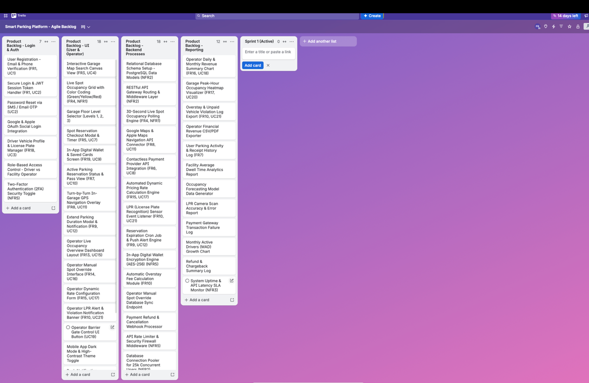
Figure 1: Smart Parking Platform Product Backlog.

7.2 Sprint 1
Nine backlog items were selected for Sprint 1, focusing on foundational system infrastructure and core user functionality.

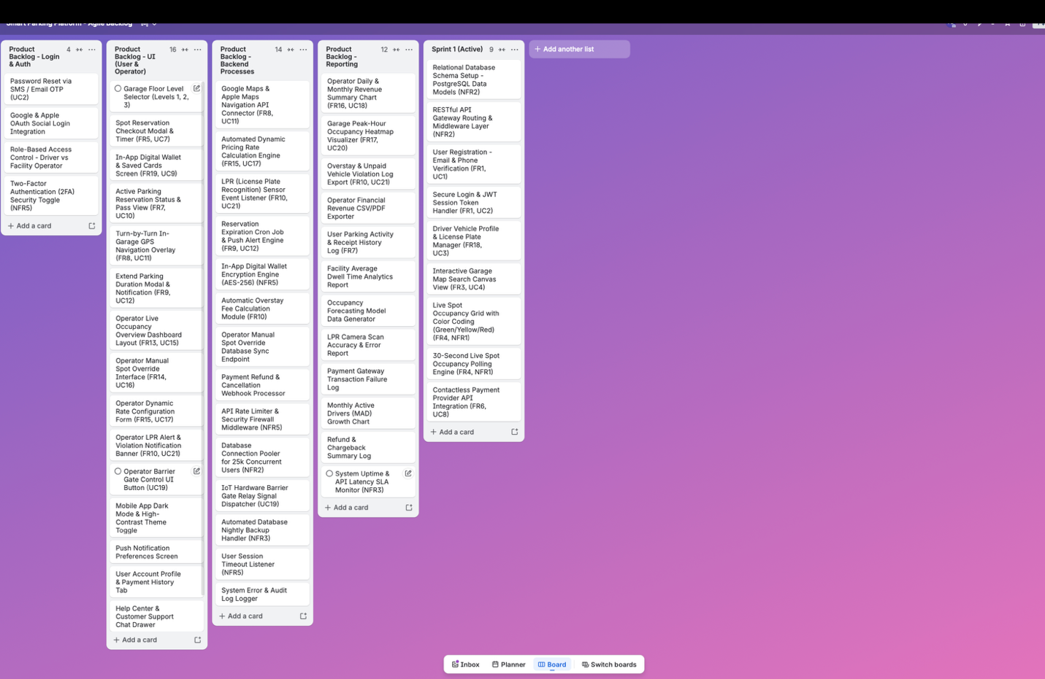
Figure 2: Smart Parking Platform Sprint 1 Backlog

8.) Risk, Quality, and Communication Management
To ensure the stability of the Smart Parking Platform potential uncertainties have been categorized into four risk categories: Technical, Schedule, Financial, and People risks (abbreviated as TR, SR, FR, and PR respectively)

8.1 Risk Identification

A. Technical Risks
- TR1 (LPR System/API Connection Failure): The connection between compatible License Plate Recognition (LPR) systems and the Smart Parking Platform could experience network or API failures, preventing vehicle identification.
- TR2 (Real-Time Availability Server Overload): High driver concurrency during peak hours could cause API response delays and interfere with the system's required 30-second live parking availability updates.
- TR3 (Payment Gateway Timeout): Third-party payment services (Such as Apple Pay or any online banking card connected) could experience connection failures or timeouts while processing digital parking transactions.
- TR4 (Third-Party Mapping API Unavailability): Google Maps or Apple Maps services could experience downtime or other service limitations, temporarily interfering with location search and navigation functionality.
Note: These risks directly correspond to functionality already established in the SRS and WBS.

B. Schedule Risks
- SR1 (Third-Party API Integration Delays): Delays in obtaining or configuring access to third-party payment or mapping services could postpone integration and testing activities.
- SR2 (Garage Data Integration Delays): Delays in obtaining access to compatible garage occupancy data could postpone integration and testing of real-time parking availability.
- SR3 (Scope Creep): Requests for additional functionality beyond the established SRS (perhaps at the behest of garage operators for example) could increase development work and delay completion of planned project activities.
- SR4 (Academic and Project Deadline Conflicts): Academic responsibilities and overlapping course deadlines could reduce team availability and affect completion of project work within the single-semester timeline.

C. Financial Risks
- FR1 (Third-Party API Usage Cost Escalation): Increased use of external mapping or other third-party services could increase operational API costs.
- FR2 (Garage Integration and Hardware Compatibility Costs): Integrating the platform with different existing garage technologies could create additional compatibility and integration expenses.
- FR3 (Cloud Infrastructure Scaling Costs): Supporting high levels of concurrent users and real-time parking data could increase cloud infrastructure and database operating costs.
- FR4 (Payment Processing and Chargeback Costs): Digital parking transactions could generate additional payment processing expenses or chargeback-related costs.

D. People & Team Risks
- PR1 (Key Team Member Unavailability): Illness, withdrawal, or extended absence of a team member responsible for an important project component could delay development.
- PR2 (Technical Skill Gaps): Limited team experience with APIs, IoT data integration, LPR systems, or other technologies required by the platform could increase development and testing time.
- PR3 (Miscommunication Across Project Components): Poor coordination between work involving the driver interface, operator portal, and backend infrastructure could result in incompatible designs or duplicated work.
- PR4 (Uneven Workload Distribution): Uneven assignment of sprint and documentation responsibilities could delay completion of project tasks and reviews.

8.2 Project Risk Register
Each risk is scored from 1 to 5 for probability and impact, then paired with a response strategy (Avoid, Mitigate, Transfer, or Accept).

Risk ID | Risk Description | Category | Prob. (1–5) | Impact (1–5) | Risk Level | Response Strategy | Risk Owner | Mitigation & Response Plan
TR1 | LPR System/API Connection Failure | Technical | 3 | 4 | High | Mitigate | Technical Team | Monitor LPR system connectivity and provide an alternative manual vehicle-verification process when LPR data are unavailable.
TR2 | Real-Time Availability Server Overload | Technical | 3 | 4 | High | Mitigate | Backend Team | Conduct load testing and optimize API/data handling to support 25,000 concurrent users and 30-second availability updates.
TR3 | Payment Gateway Timeout | Technical | 2 | 5 | High | Mitigate | Backend Team | Implement transaction error handling, retry procedures, and transaction verification for failed or delayed payment requests.
TR4 | Third-Party Mapping API Unavailability | Technical | 2 | 3 | Medium | Mitigate | Development Team | Implement error handling and notify users when external mapping/navigation services are temporarily unavailable.
SR1 | Third-Party API Integration Delays | Schedule | 3 | 3 | Medium | Mitigate | Project Team | Begin integration preparation early and use mock data or services during development when third-party access is unavailable.
SR2 | Garage Data Integration Delays | Schedule | 3 | 4 | High | Mitigate | Project Team | Use representative occupancy data for development and testing while compatible garage-data integration is established.
SR3 | Scope Creep Beyond SRS | Schedule | 4 | 3 | High | Avoid | Project Team | Maintain established SRS boundaries and formally evaluate requested changes before adding new functionality.
FR3 | Cloud Infrastructure Scaling Costs | Financial | 3 | 3 | Medium | Accept | Project Team | Monitor infrastructure usage and scaling requirements as system load increases.
PR1 | Key Team Member Unavailability | People | 2 | 4 | Medium | Mitigate | Project Team | Maintain project documentation and distribute knowledge so critical work can be continued by another team member.
PR2 | Technical Skill Gaps | People | 3 | 3 | Medium | Mitigate | Project Team | Review relevant technical documentation and conduct focused research and testing before implementing unfamiliar integrations.

8.3 Quality Management Plan (QA vs. QC)
Quality of our Product is maintained through a combination of process-oriented Quality Assurance (QA) and product-oriented Quality Control (QC), their roles have been provided below:
- Quality Assurance (QA – Process Focused): Focuses on preventing defects by establishing and reviewing the processes used to develop the system. QA activities include peer review checklists, code reviews, formal release testing procedures, and the use of a staging environment before release.
- Quality Control (QC – Product Focused): Focuses on detecting defects in the completed or functioning product. QC activities include test execution and automated regression testing to identify defects and verify that system functionality continues to meet project requirements.

8.4 Communication Plan & Stakeholder Management
To maintain alignment between the WE ARE $oftware ¢orp. project team and project stakeholders, the Smart Parking Platform utilizes established communication channels, recurring meetings, and stakeholder reporting methods described below:

A. Team Communication Channels l
Communication will be centralized to ensure that information is shared consistently between the project lead and the functional areas of the project, including the Driver Application, Parking Operator Portal, Backend & Integration Infrastructure, and Quality Assurance activities.

Team communication channels will be used for day-to-day coordination, while GitHub and Trello will maintain project documentation, task assignments, backlog items, and development progress.

Communication complexity will be considered as the project team expands. The number of possible communication channels is calculated using N(N−1)/2, where N represents the number of team members.

B. Team Meeting Cadence
- Daily Stand-Up (15 Minutes): Development team members briefly report what they completed yesterday, what they plan to work on today, and any blockers preventing progress.
- Weekly Project Progress Meeting: The project lead reviews completed and outstanding work, Trello backlog progress, GitHub documentation updates, upcoming deadlines, and changes to identified project risks.
- Weekly Stakeholder Update (1–2 Minutes): A short progress update is provided to the project stakeholder/investor representative summarizing completed work, current project status, and the next planned activities.
- Monthly Sprint & Stakeholder Review: A higher-level review is conducted to demonstrate completed functionality, evaluate sprint progress, discuss major risks or issues, and confirm upcoming project priorities.

C. Stakeholder Reporting Methods
- Project Stakeholder / Investor Representative: Receives concise weekly progress updates and demonstrations focused on project status, completed milestones, major risks, and upcoming work.
- Project Lead and Development Teams: Use Trello to manage backlog items and project tasks and GitHub to maintain project documentation and development progress.
- Formal Project Reporting: Dashboards, progress reports, and demonstrations are used to communicate project status at the appropriate level of detail for the intended audience.

